## A Project Report

*On*

**BLOCKCHAIN-BASED CARBON CREDIT ECOSYSTEM**

*Submitted to the*

### Savitribai Phule Pune University

*In partial fulfillment for the award of the Degree of*

**BE in Information Technology**

*By*

|  |  |
| --- | --- |
| **Exam Seat No** | **Name** |
| BE22IT071 | Amol Netke |
| BE22IT072 | Yogesh Zade |
| BE22IT074 | Harsh Satwani |
| BE22IT076 | Yuvrajsing Solanke |

*Under the guidance of*

**Mrs. Parvati Bhadre**



**Department Of Information Technology**

**D. Y. Patil College Of Engineering, Akurdi, Pune - 411044**

**2024-25**



**CERTIFICATE**

This is to certify that the Project Stage 1 **‘BLOCKCHAIN-BASED CARBON CREDIT ECOSYSTEM’** being submitted by

|  |  |
| --- | --- |
| **Exam Seat No** | **Name** |
| BE22IT071 | Amol Netke |
| BE22IT072 | Yogesh Zade |
| BE22IT074 | Harsh Satwani |
| BE22IT076 | Yuvrajsing solanke |

is a record of bonafide work carried out by him/her under the supervision and guidance of project Guide **Mrs. Parvati Bhadre** in partial fulfillment of the requirement for **BE (Information Technology Engineering) – 2019 course** of Savitribai Phule Pune University, Pune in the academic year 2024- 2025.

Date:

Place: Akurdi, Pune.

#### Mrs. Parvati Bhadre Dr. Preeti Patil

Guide Head of the Department

This Project Stage 1 report has been examined by us as per the Savitribai Phule Pune University, Pune, requirements at D. Y. Patil College of Engineering on date.

(Name & Signature) (Name & Signature)

Internal Examiner External Examiner

## ACKNOWLEDGEMENT

With immense pleasure, we present the Project report as part of the curriculum of the **B.E. Information Technology Engineering**. We wish to thank all the people who gave us an unending support right from when the idea was conceived. We express sincere and profound thanks to Project Guide **Mrs. Parvati Bhadre,** and **Dr. Preeti Patil, Head, Department of Information Technology** who is ready to help with the most diverse problems that they have encountered along the way. We express sincere thanks to all staff and colleagues who have helped directly or indirectly in completing this seminar successful.

Name of students:

1. Amol Netke - 71
2. Yogesh Zade - 72
3. Harsh Satwani - 74
4. Yuvrajsing Solanke - 76

**TABLE OF CONTENTS**

1. Introduction…………………………………………………………………………….....
2. Literature Survey.................................................................................................................
3. Problem Statement/Definition .
4. Software Requirements Specification……………………………………………………..
5. Project Requirements Specification………………………………………………………
6. Proposed System Architecture……………………………………………………………
7. High Level Design of the project……………………………….……………………………...
8. System Implementation………………… ………………………………………………..

9. Proposed GUI/Working modules/Experimental Results…………………………………..

10. Project Plan……………………………………………………………………………………

11. Conclusion………………………………………………………………………………………

**LIST OF TABLES**

|  |  |  |  |
| --- | --- | --- | --- |
| **Sr, No.** | **Table** | **Name** | **Page No.** |
| 1. | 2.1 | Literature Survey |  |
| 2. | 10.1 | Project Plan |  |

**LIST OF FIGURES**

|  |  |  |  |
| --- | --- | --- | --- |
| **Sr, No.** | **Figure** | **Name** | **Page No.** |
| 1. | 7.1 | Data Flow Diagram |  |
| 2. | 7.2 | ER Diagram |  |
| 3. | 9.1 | User Selection Page |  |
| 4. | 9.2 | User Selection Page |  |
| 5. | 9.3 | Login Page |  |
| 6. | 9.4 | Registration Page |  |
| 7. | 9.5 | User Dashboard |  |
| 8. | 9.6 | Connect MetaMask Wallet |  |
| 9, | 9.7 | Connect MetaMask Wallet |  |
| 10. | 9.8 | MetaMask Address |  |

# Abstract

Climate change and global warming are critical issues of our time. One way to address these challenges is by reducing greenhouse gas emissions through a global carbon trading system. A carbon credit is a permit that allows the holder to emit a specific amount of carbon dioxide or other greenhouse gases, with one credit typically representing one ton of carbon dioxide. These credits can be bought, sold, or traded, creating a financial incentive for companies to reduce their emissions. However, current carbon credit systems face problems like fragmentation, lack of transparency, and high transaction costs that benefit intermediaries rather than the environment. Our project proposes a blockchain-based Carbon Credit Ecosystem to solve these issues. By using smart contracts and blockchain technology, we aim to make carbon markets more transparent, accessible, and efficient. The ecosystem will include a tokenization mechanism for securely digitizing carbon credits, clear protocols for creating and retiring these credits, and a transparent system for their distribution and trading. Additionally, we will engage all relevant stakeholders, such as the energy industry, project verifiers, liquidity providers, NGOs, citizens, and governments, ensuring that the system benefits everyone involved. This model could also be applied to other credit and trading systems.

# Introduction

## 

## Aim

The aim of this project is to develop a secure, transparent, and decentralized Blockchain-Based Carbon Credit Ecosystem that addresses the inefficiencies of traditional carbon credit systems. By leveraging blockchain technology, the project aims to ensure the integrity and authenticity of carbon credits through immutable records and decentralized verification processes. The system will facilitate the automated issuance, trading, and retirement of carbon credits using smart contracts, reducing the risk of fraud, double-counting, and mismanagement. Ultimately, this project seeks to enhance the global carbon credit market by promoting trust, efficiency, and accessibility for all stakeholders, thereby encouraging broader participation in efforts to mitigate climate change.

## Objective

## Enhance Transparency:

* + - * Develop a blockchain-based platform that ensures full transparency in every step of the carbon credit lifecycle, from issuance to trading and retirement, thereby reducing risks such as over-crediting and double-spending.
      * Utilize smart contracts to automate and publicly record all transactions, making them easily auditable by any participant in the ecosystem.

## Standardize Carbon Credit Systems:

* + - * Establish clear and consistent protocols for the tokenization, minting, and burning of carbon credits to ensure uniformity and reliability across global markets.
      * Create a universally accepted digital standard for carbon credits that can be integrated across different regulatory environments and industries.

## Reduce Transaction Costs:

* + - * Implement a decentralized platform that minimizes reliance on intermediaries, thereby reducing transaction costs and streamlining the process of carbon credit trading.
      * Develop automated processes for trading and verifying carbon credits, cutting down administrative overhead and time delays.

## Increase Accessibility:

* + - * Design an intuitive user interface that allows diverse stakeholders—including large corporations, small businesses, NGOs, and individual citizens—to easily access and participate in carbon credit markets.
      * Enable global participation by offering multi-language support and compliance with various regional regulations.

## Promote Liquidity:

* + - * Introduce an automated market maker (AMM) mechanism to maintain a highly liquid market for carbon credits, allowing participants to buy and sell credits at any time without significant price slippage.
      * Encourage the participation of liquidity providers by offering incentives and rewards for maintaining market liquidity.

## Support Global Sustainability Goals:

* + - * Align the platform with international sustainability goals, ensuring that it contributes effectively to the reduction of global greenhouse gas emissions.
      * Collaborate with global organizations and initiatives to integrate the platform into broader climate action strategies.

# Literature Survey

# 

|  |  |  |  |
| --- | --- | --- | --- |
| Sr. No. | Paper | Author | Abstract |
| 1. | A Blockchain-based Carbon Credit Ecosystem (2022) | Dr. Soheil Saraji,Dr. Mike Borowczak | This paper addresses the challenges of climate change by proposing a carbon trading system utilizing smart contracts and blockchain technology. The system aims to enhance transparency, accessibility, and liquidity in carbon markets by eliminating intermediaries and reducing transaction costs. It facilitates greater stakeholder participation and provides a robust framework for trading carbon credits, ultimately contributing to global efforts in combating climate change. |
| 2. | Blockchain and the carbon credit ecosystem: Sustainable management of the supply chain (2023) | Preetam Basu, Palash Deb,Akhilesh Singh | This research paper explores the integration of blockchain technology in the carbon credit ecosystem. It emphasizes the sustainable management of the supply chain through enhanced traceability and accountability. By leveraging blockchain, the paper highlights the potential to optimize carbon credit transactions, reduce fraud, and improve stakeholder engagement, ultimately contributing to a more efficient and transparent carbon market. |

# Table 2.1

# Problem Statement/Definition

*Fragmented standards, lack of transparency, and high transaction costs undermine the effectiveness of carbon credit systems. A streamlined, transparent, and efficient approach is crucial to enhance trust and ensure genuine emission reductions.*

Current carbon credit systems are plagued by significant challenges that hinder their effectiveness in combating climate change. These challenges include fragmented implementations across different regions and platforms, which result in inconsistent standards and practices. Additionally, there is a lack of transparency in how carbon credits are issued and traded, leading to issues like over-crediting, where more credits are issued than the actual reduction in emissions, and double-spending, where the same credit is used multiple times.

Moreover, the high transaction costs associated with these systems disproportionately benefit intermediaries, such as brokers and agents, rather than contributing to environmental sustainability. These inefficiencies not only reduce the overall impact of carbon trading but also limit participation and trust in the system.

To address these issues, a more transparent, standardized, and accessible approach is needed—one that leverages technology to enhance the integrity and efficiency of carbon markets, ensuring that they truly contribute to reducing greenhouse gas emissions on a global scale.

# Software Requirements Specification

The purpose of this Software Requirements Specification (SRS) document is to provide a comprehensive and detailed description of the features, functionalities, and behaviors of the **Blockchain-Based Carbon Credit Ecosystem**. This document serves as a foundational blueprint for the development and implementation of the platform, ensuring that all stakeholders, including developers, project managers, regulators, and users, have a clear understanding of the system's goals and operational requirements.

The platform is designed to revolutionize the carbon credit market by leveraging blockchain technology to create a secure, transparent, and efficient environment for the issuance, trading, and retirement of carbon credits.

. **4.1. Functional Requirements**

##### **User Registration & Authentication**

* Users must create accounts or log in using existing credentials.
* KYC procedures will be implemented to verify the identity of users.
* Authentication support for email, phone, and social media (Google, Facebook).

##### **Carbon Credit Issuance**

* Environmental projects can submit documentation for certification.
* Upon successful verification, smart contracts will tokenize and issue carbon credits automatically.

##### **Trading Platform**

* Users can buy, sell, and trade carbon credits in real-time through the marketplace.
* Automated Market Maker (AMM) protocols ensure liquidity and reduce price slippage during transactions.

##### **Smart Contracts**

* All transactions (buying, selling, retiring) are managed via automated smart contracts to ensure security and transparency.

### Non-Functional Requirements

##### **Performance Requirements**

* The system must support at least **10,000 concurrent users** with minimal latency.
* Transaction confirmation times should be under **5 seconds**.

##### **Security Requirements**

* All user data must be **encrypted** to ensure privacy and security.
* Compliance with **GDPR** and **COPPA** regulations for data protection.
* Implement **multi-factor authentication (MFA)** for user accounts.

##### **Usability Requirements**

* The platform should feature a **user-friendly** and intuitive interface.
* Provide a **comprehensive onboarding process** to educate users about carbon credits and blockchain technology.

##### **Compatibility Requirements**

* The platform will support cross-platform usage, including **desktop**, **web**, and **mobile** applications.
* Ensure compatibility with major operating systems: **Windows**, **macOS**, **Android**, and **iOS**.

##### **Scalability**

* The backend architecture should scale **horizontally** to accommodate an increasing user base.
* The blockchain infrastructure must support an increasing volume of transactions over time

1. **Project Requirements Specification**

# Software Requirements

# Blockchain Platform:

* + 1. Ethereum (or any other suitable blockchain platform like Hyperledger or Polkadot)

## Smart Contract Development:

* + 1. Solidity (for Ethereum-based smart contracts)
    2. Remix IDE (for writing, testing, and deploying smart contracts)
    3. Truffle Suite (for development, testing, and deployment of smart contracts)

## Decentralized Application (dApp) Development:

* + 1. Web3.js or Ethers.js (for integrating smart contracts with the front-end)
    2. React.js or Angular (for building the front-end interface of the dApp)
    3. Node.js (for back-end development)
    4. IPFS (InterPlanetary File System) for decentralized storage

## Database:

* + 1. MongoDB or PostgreSQL (for off-chain data storage and management)
    2. Redis (for caching and real-time data processing)

## Security and Compliance:

* + 1. OpenZeppelin (for security audits and using secure smart contract libraries)
    2. Gnosis Safe (for secure multi-signature wallets)

## Monitoring and Analytics:

* + 1. The Graph (for indexing blockchain data)
    2. Grafana or Kibana (for real-time monitoring and data visualization)

## Development Environment:

* + 1. Git (for version control)
    2. Docker (for containerization and managing microservices)
    3. Jenkins or GitHub Actions (for CI/CD)

# Hardware Requirements

* Processor: Intel i5 or AMD Ryzen 5
* RAM: 8 GB minimum
* Storage: 512 GB SSD
* Cloud-based servers: AWS, Azure, or Google Cloud
* High-speed internet connection for development and deployment tasks.

# Proposed System Architecture

We aim to create a Blockchain-based Carbon Credit Ecosystem that enhances liquidity, transparency, accessibility, and standardization in carbon markets. This ecosystem will integrate all stakeholders, including carbon credit generators and consumers, into a unified platform. Key features include:

* + - * **Tokenization Mechanism:** Clear protocols for minting and burning carbon tokens.
      * **Transparent Distribution:** A system for equitable token distribution.
      * **Automated Market Maker (AMM):** Facilitates trading of carbon tokens, driven by supply and demand dynamics.

The ecosystem involves several key stakeholders:

* + - * **Generators:** Entities like wind farms, reforestation projects, and CO2 sequestration initiatives that generate carbon credits.
      * **Consumers:** Carbon emitters or polluters, such as those in the energy sector, who purchase carbon credits.
      * **Validators:** Accredited and globally distributed experts who validate carbon credits and onboard projects to the platform. They help ensure that the carbon credits are genuine and properly represented.

The process includes:

* + - * **Tokenization:** Carbon credits are converted into digital tokens on the blockchain. Validated projects receive these tokens.
      * **Trading Platform:** A decentralized exchange allows buyers and sellers to trade carbon tokens. Prices are determined by market forces.
      * **Burning Mechanism:** Carbon tokens are retired using a "buy and burn" model, where tokens are sent to a smart contract or blockchain address with restricted access. Successful token burns are rewarded with non-fungible tokens (NFTs) representing carbon removal certificates.
  1. **Smart Contracts**

The system will utilize four key smart contracts, each serving a specific function and interacting with stakeholders and liquidity providers. The design includes:

## Smart Contract 1: Registry System

To record essential information for stakeholders, including:

* + **Verifiers:** Validate carbon credits and ensure the burnt tokens correspond to actual emissions reductions.
  + **Credit-holders:** Organizations that possess carbon credits within the trading ecosystem.
  + **Customers:** Individuals and companies buying and retiring carbon credits.

## Smart Contract 2: Token Management

* + Approve carbon credits entered by credit-holders, as certified by verifiers.
  + Mint carbon tokens based on approved credits.
  + Enable transfer and burning of carbon tokens.
  + Issue NFTs as certificates for successfully retired carbon tokens.

## Smart Contract 3: Multi-Signature Verification

* + **To** facilitate verification of carbon token minting and burning.
  + **R**equires approval from at least 70% of verifiers before execution.

## Smart Contract 4: Automated Market Maker (AMM)

* + Automate trading of carbon tokens against digital currencies (e.g., stablecoins or future central bank digital currencies).
  + Incentivize liquidity providers through transaction fees (e.g., 0.3%) shared among them.
  + Provide dynamic pricing for carbon tokens based on market activity
  1. **Frontend**

The frontend of the Blockchain-based Carbon Credit Ecosystem provides a user-friendly interface for interacting with the system. Key features include:

## User Dashboard:

* Centralized view of user activities, including carbon credits, tokens, and transactions.
* Notifications for important updates and events.

## Carbon Credit Management:

* Interfaces for carbon credit generators to submit projects and for buyers and sellers to trade tokens.
* Tools for tracking market trends and transaction history.

## Verification and Validation:

* Dashboards for validators to review and approve credits.
* Audit trail for verification activities to ensure transparency.

## Marketplace Interaction:

* Integration with the Automated Market Maker (AMM) for trading carbon tokens and viewing liquidity pools.

## Security Features:

* Secure login with multi-factor authentication (MFA) and data encryption to protect user information.

## Technology Stack:

* **Frontend Framework:** React.js
* **Web3 Integration:** Web3.js or Ethers.js
* **Styling:** CSS or frameworks like Bootstrap or Material-UI

1. **High Level Design**

**Fig. 7.1. Data Flow Diagam (DFD)**

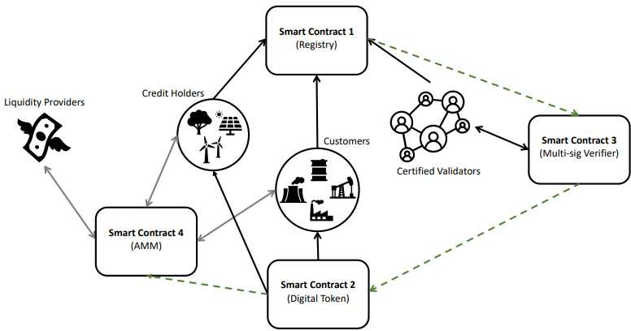

**Fig. 7.2. Entity Relationship (ER) Diagram**

1. **System Implementation**

The implementation of the Blockchain-Based Carbon Credit Ecosystem provides a robust solution to the challenges faced in the current carbon credit market. By leveraging blockchain technology, smart contracts, and user-friendly applications, the system enhances the integrity, transparency, and efficiency of carbon credit transactions, thereby contributing to global sustainability efforts.

### ****Implementation Steps****

1. **Setting Up the Blockchain Environment**:
   * Install the Ethereum development framework (e.g., Truffle or Hardhat).
   * Configure the smart contracts and deploy them to the Ethereum test network.
2. **Developing the Web and Mobile Applications**:
   * Set up the React.js application for the web interface.
   * Use React Native to create the mobile app for Android and iOS.
3. **Integrating Smart Contracts**:
   * Use web3.js to interact with the deployed smart contracts from the web and mobile applications.
   * Implement necessary functions for issuing, trading, and retiring carbon credits.
4. **Testing**:
   * Conduct unit testing for smart contracts using tools like Mocha and Chai.
   * Perform end-to-end testing for the web and mobile applications.
5. **Deployment**:
   * Deploy the web application on a cloud platform (e.g., AWS, Heroku).
   * Publish the mobile application on app stores (Google Play Store and Apple App Store).
6. **Proposed GUI/ Working modules/ Experimental Results**

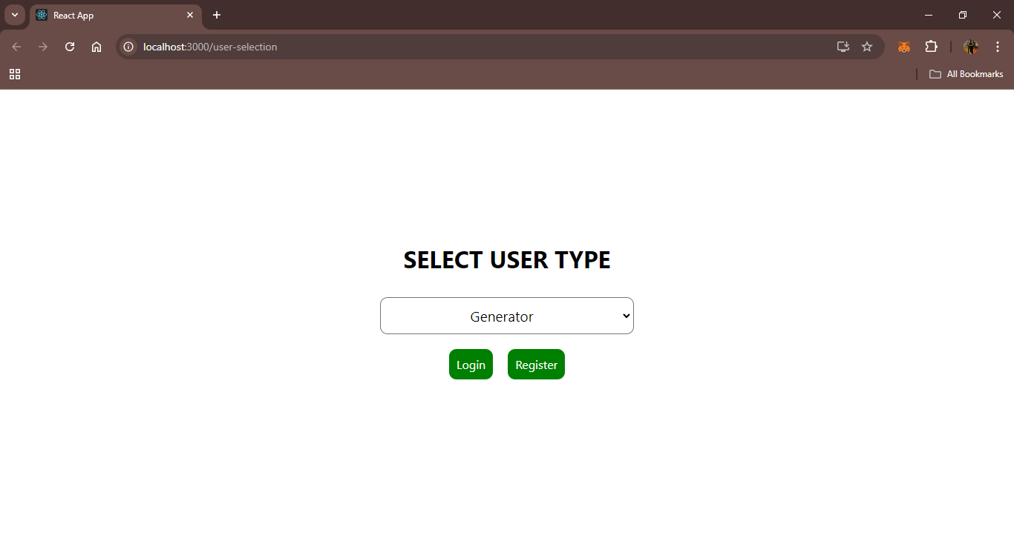

**Fig. 9.1. User Selection Page**

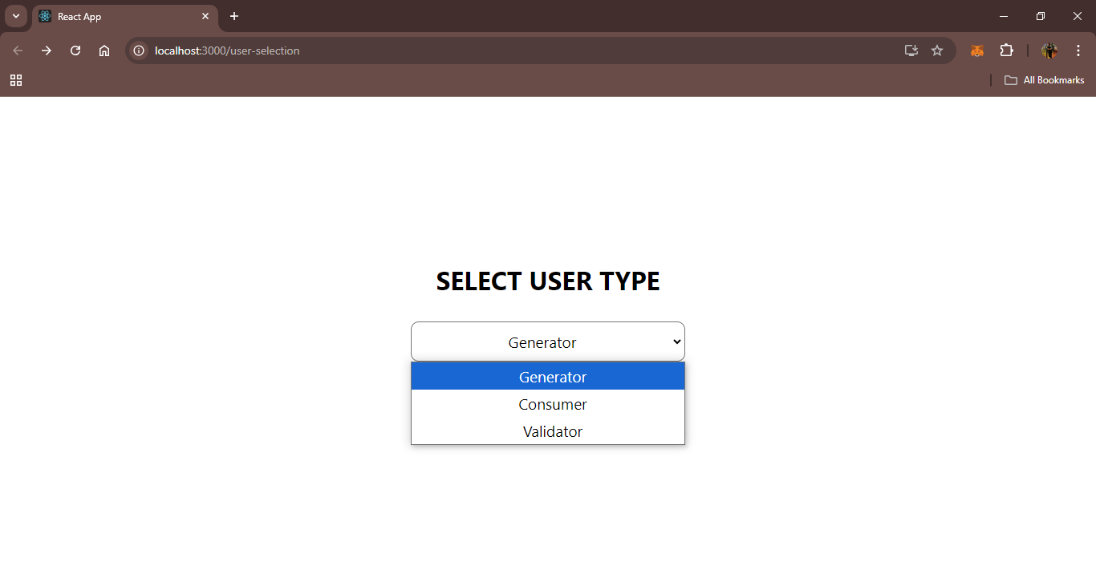

**Fig 9.2 User Selection Page**

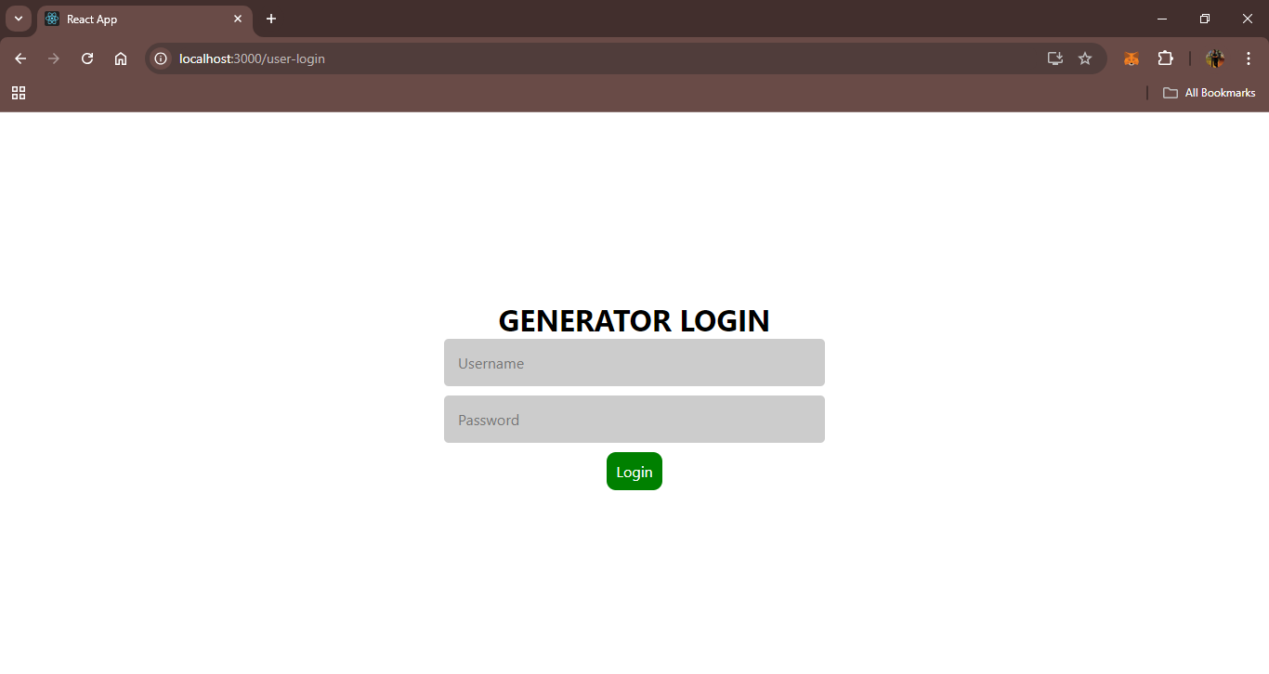

**Fig. 9.3. Login Page**

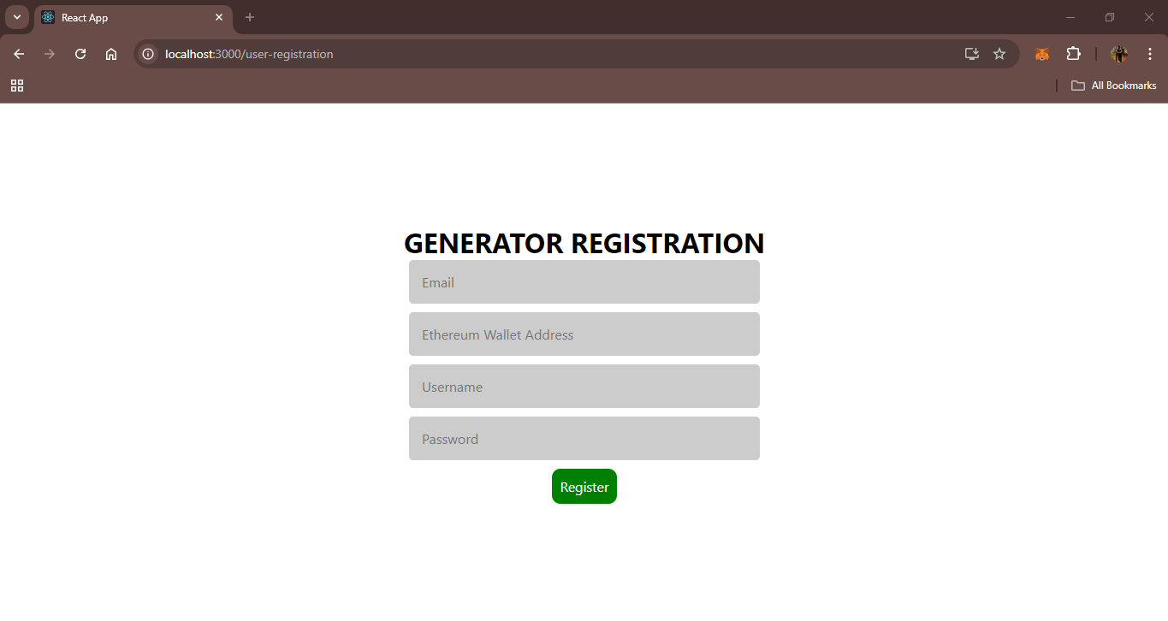

**Fig. 9.4. Registration Page**

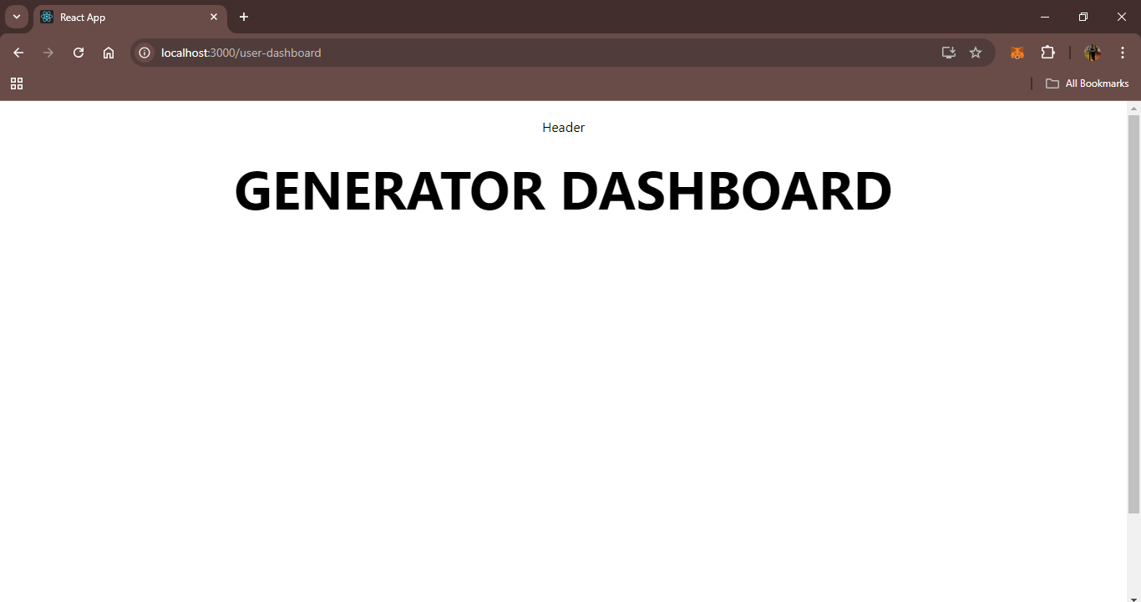

**Fig. 9.5. User Dashboard**

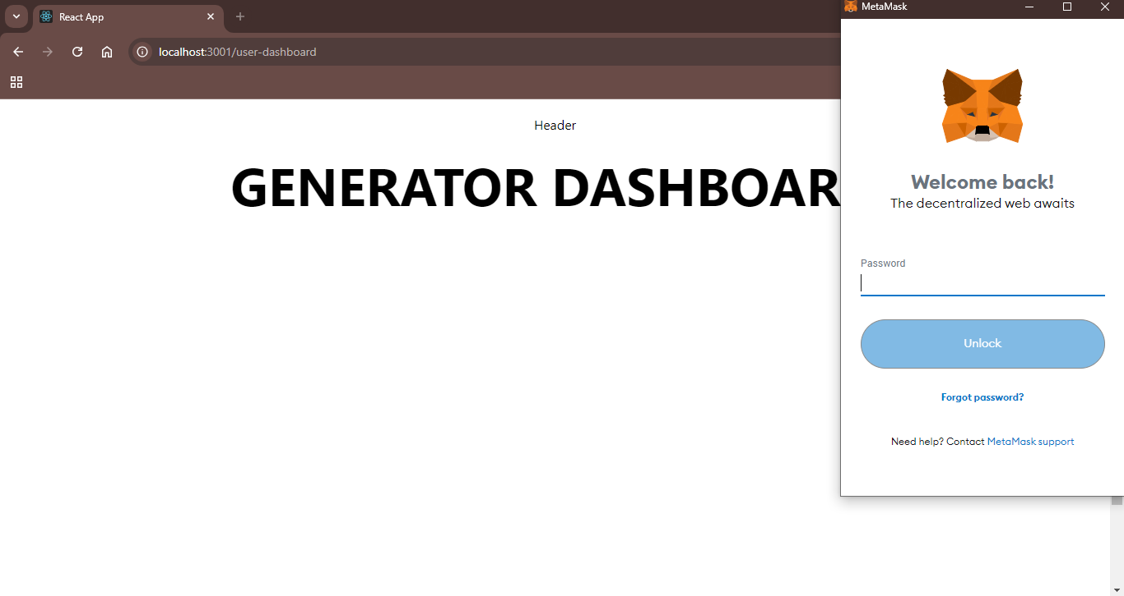

**Fig. 9.6. Connect MetaMask Wallet**

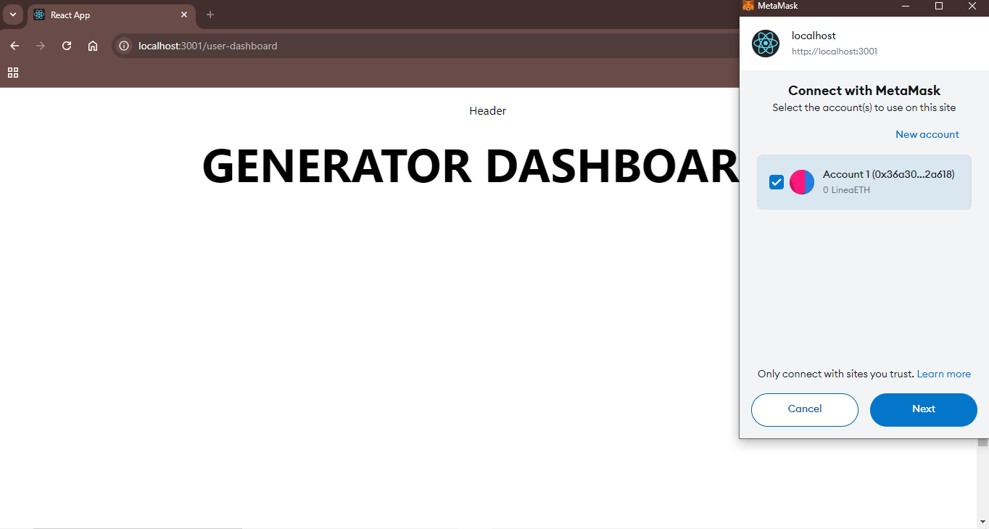

**Fig. 9.7. Connect MetaMask Wallet**

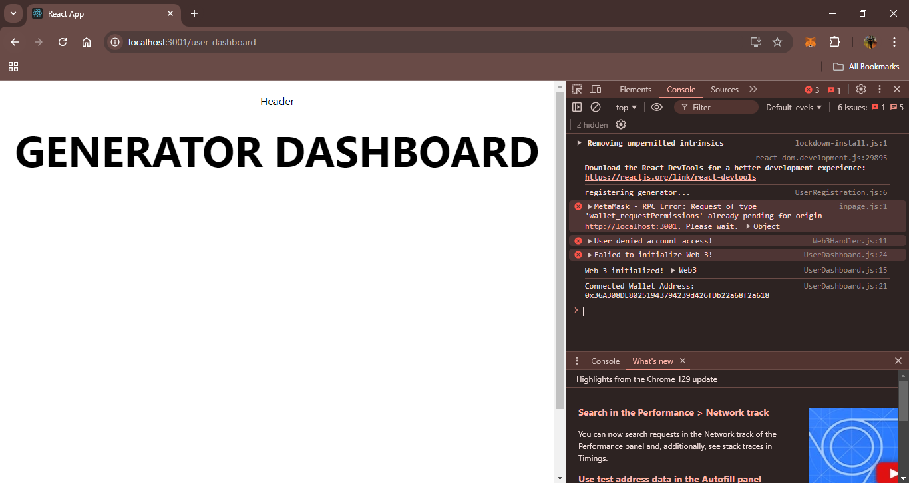

**Fig. 9.8. MetaMask Wallet Address**

**10. Project Plan**

|  |  |  |  |
| --- | --- | --- | --- |
| **Phase** | **Objective** | **Tasks** | **Timeline** |
| **1. Requirements Gathering and Analysis** | Identify key requirements for the carbon credit ecosystem. | * Conduct stakeholder interviews and surveys. * Define system requirements and user stories. * Analyze existing carbon credit systems and identify gaps. | 2-3  weeks |
| **2. System Architecture Design** | Develop a comprehensive system architecture for the platform. | * Design blockchain network (node structure, consensus mechanisms, smart contract framework). * Define data flow diagrams, ER models, and user interaction flows. | 3-4  weeks |
| **3. Development of Blockchain Platform** | Implement the core blockchain platform. | * Set up the blockchain infrastructure (Ethereum or Hyperledger Fabric). * Develop and deploy smart contracts. * Implement the decentralized marketplace. | 6-8  weeks |
| **4. Integration of IoT and Data Oracles** | Ensure real-time data integration for accurate monitoring. | * Integrate IoT devices for data collection. * Connect data oracles to feed external data. * Test data integration for accuracy and reliability. | 4-5  weeks |
| **5. User Interface and Experience Design** | Develop an intuitive and accessible user interface. | * Design UI wireframes and prototypes. * Develop front-end application. * Ensure responsiveness and accessibility across devices. | 3-4  weeks |
| **6. Testing and Quality Assurance** | Validate functionality, security, and performance of the platform. | * Conduct unit, integration, and system testing. * Perform security audits and penetration testing. * Gather user feedback through beta testing. | 4-5  weeks |
| **7. Deployment and Launch** | Deploy the platform to a live environment and begin operations. | * Conduct final testing and quality checks. * Launch with initial users and projects. | 2 weeks |
| **8. Post-Launch Support and Maintenance** | Ensure smooth operation and continuous improvement. | * Provide ongoing technical support. * Monitor system performance and implement updates. * Gather feedback for future enhancements. | 1 week |

**Table 10.1**

# 11. Conclusion

The Blockchain-Based Carbon Credit Ecosystem represents a significant advancement in the way carbon credits are managed and traded. By leveraging blockchain technology, the project aims to create a more transparent, efficient, and trustworthy system for carbon offsetting. The ecosystem addresses key challenges in the current market, such as the lack of transparency, inefficiencies in verification processes, and the potential for fraud.Through this project, stakeholders will benefit from a decentralized and secure platform that automates the lifecycle of carbon credits, from issuance to retirement. The integration of IoT devices and data oracles ensures real-time and accurate monitoring of environmental impact, enhancing the credibility of carbon credits. Moreover, the decentralized marketplace will foster greater market liquidity and allow for peer-to-peer trading, reducing transaction costs and barriers to entry.

# References

# Dr. Soheil Saraji & Dr. Mike Borowczak - A blockchain-based carbon credit ecosystem (2022) – White paper

# Preetam Basu, Palash Deb & Akhilesh Singh - Blockchain and the carbon credit ecosystem: Sustainable management of the supply chain (2023) - Journal of Business Strategy - ISSN 0275-6668